**1. Explain DAX**

**Ans:**

\***DAX or Data Analysis**\* Expressions drive all the calculations you can perform in Power BI. DAX formulas are versatile, dynamic, and very powerful – they allow you to create new fields and even new tables in your model. While DAX is most commonly associated with Power BI, you can also find DAX formulas in Power Pivot in Excel and SQL Server Analysis Services (SSAS).

DAX formulas are made up of 3 core components and this tutorial will cover each of these:

* Syntax – Proper DAX syntax is made up of a variety of elements, some of which are common to all formulas.
* Functions – DAX functions are predefined formulas that take some parameters and perform a specific calculation.
* Context – DAX uses context to determine which rows should be used to perform a calculation.

There are three ways you can use DAX formulas in Power BI:

* Calculated Tables - These calculations will add an additional table to the report based on a formula.
* Calculated Columns - These calculations will add an additional column to a table based on a formula. These columns are treated like any other field in the table.
* Measures - These calculations will add a summary or aggregated measure to a table based on a formula.

The main difference between these three types of calculations is in their context (more on this later) and the outputs they produce.

DAX formulas are intuitive and easy to read. This makes it easy to understand the basics of DAX so you can start writing your own formulas relatively quickly. Let’s go over the building blocks of proper DAX syntax.

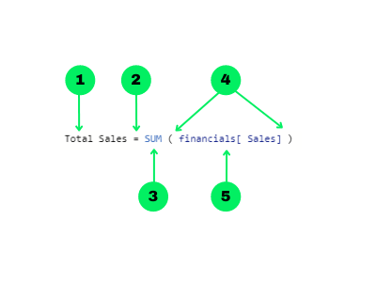

1. The name of the measure or calculated column
2. The equal-to operator (“=”) indicates the start of the formula
3. A DAX function
4. Opening (and closing) parentheses (“()”)
5. Column and/or table references

Note that each subsequent parameter in a function is separated by a comma (“,”)

Some of the most common DAX functions used in reports are:

1. Simple calculations: COUNT, DISTINCTCOUNT, SUM, AVERAGE, MIN, MAX.
2. SUMMARISE: Returns a table typically used to further apply aggregations over different groupings.
3. CALCULATE: Performs an aggregation along with one or more filters. When you specify more than one filter, the function will perform the calculation where all filters are true.
4. IF: Based on a logical condition, it will return a different value for if it is true or false. This is similar to the CASE WHEN operation in SQL.
5. IFERROR: Looks for any errors for an inner function and returns a specified result
6. ISBLANK: Checks if the rows in a column are blank and returns true or false. Useful to use in conjunction with other functions like IF.
7. EOMONTH: Returns the last day of the month of a given date (column reference in a date format) for as many months in the past or the future.
8. DATEDIFF: returns the difference between 2 dates (both as column references in date formats) in days, months, quarters, years, etc.

**2. Explain datasets, reports, and dashboards and how they relate to each other?**

**Ans:**

**Datasets** : A dataset is a collection of data that you import or connect to. Power BI lets you connect to and import all sorts of datasets and bring all of it together in one place. Datasets can also source data from dataflows.

Datasets are associated with workspaces, and a single dataset can be part of many workspaces. When you open a workspace, the associated datasets are listed under the Datasets tab. Each listed dataset is a source of data available for one or more reports, and the dataset can contain data that comes from one or more sources—for example, an Excel workbook on OneDrive, or an on-premises SSAS tabular dataset, or a Salesforce dataset. 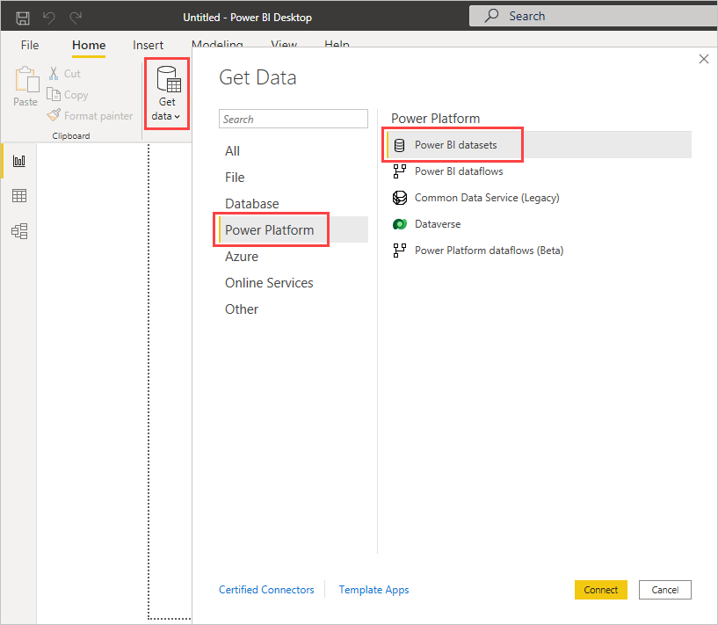

To connect to or import a dataset, select Create in the nav pane. Follow the instructions to connect to or import the specific source and add the dataset to the active workspace. New datasets are marked with a yellow asterisk. The work you do in Power BI doesn't change the underlying dataset.

Datasets added by one workspace member are available to the other workspace members with an admin, member, or contributor role. Datasets can be refreshed, renamed, explored, and removed. Use a dataset to create a report from scratch or by running quick insights. To see which reports and dashboards are already using a dataset, select View related. To explore a dataset, select it. What you're actually doing is opening the dataset in the report editor, where you can really start exploring the data by creating visualizations.

**Reports** : A Power BI report is one or more pages of visualizations such as line charts, maps, and treemaps. Visualizations are also called visuals. All of the visualizations in a report come from a single dataset. Reports can be created from scratch by you and your colleagues, and can be shared with you directly, in a workspace, or as part of an app. Sometimes Power BI creates them for you when you connect to datasets from Excel, Power BI Desktop, databases, and SaaS applications. For example, when you connect to an SaaS application, Power BI imports a pre-built report.

There are two modes to view and interact with reports: Reading view and Editing view. When you open a report, it opens in Reading view. If you have edit permissions, then you see Edit report in the upper-left corner, and you can view the report in Editing view. If a report is in a workspace, everyone with an admin, member, or contributor role can edit it. They have access to all the exploring, designing, building, and sharing capabilities of Editing view for that report. The people they share the report with can explore and interact with the report in Reading view.

**DashBoards** : A dashboard is something you create in the Power BI service or something a colleague creates in the Power BI service and shares with you. It's a single canvas that contains zero or more tiles and widgets. Each tile pinned from a report or from Q&A displays a single visualization that was created from a dataset and pinned to the dashboard. Entire report pages can also be pinned to a dashboard as a single tile.

**3. How reports can be created in power BI, explain two ways with Navigation of each.**

**Ans:**

There are several ways to create reports quickly in the Power BI service. Instead of downloading the Power BI Desktop app and importing the data, you can paste data straight into Power BI on the web, and Power BI automatically generates visuals for you.

1. **Creating Reports using the Power BI Web Tool** :

In the navigation pane in the Power BI service, you can select the Create button that opens a page where you can select your data source. It's also accessible from the New report button on Home.

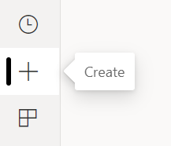

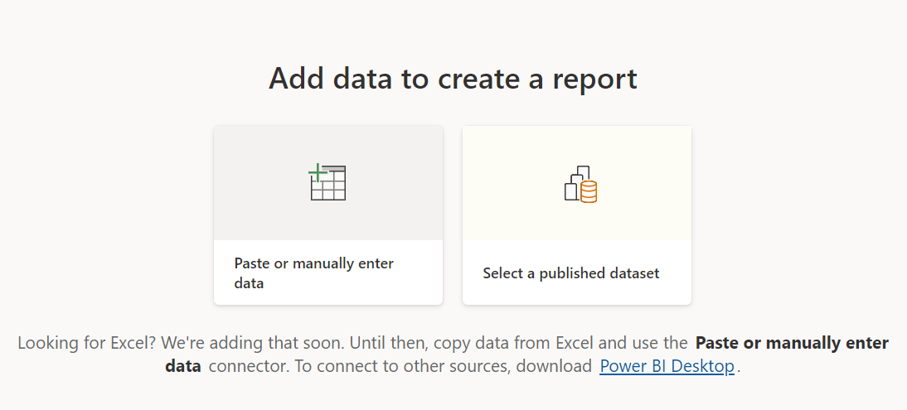

When you choose to paste or manually enter data, a grid appears that you can type into. You can also paste data by using Ctrl + V or the context menu.

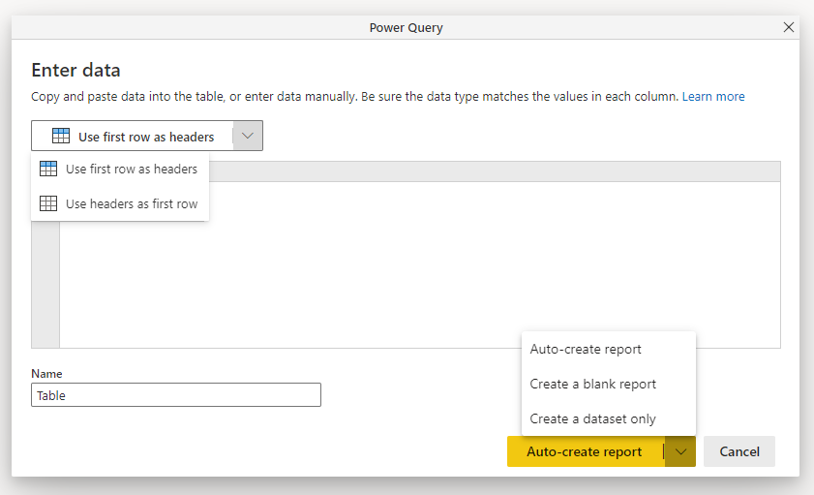

You can use the context menu to add and remove columns. If your pasted data includes a header row, select Use first row as headers to automatically promote the first row to the header row. Power BI automatically detects the data types, but you can set them manually. Select the Data type button next to the column name.

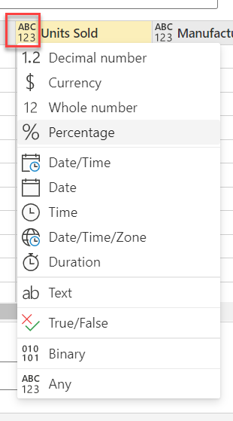

As you go through the creation process, Power BI creates a new dataset for you and autogenerates a summarized view of your data. These autogenerated visuals propel you from raw data to insights faster than ever.

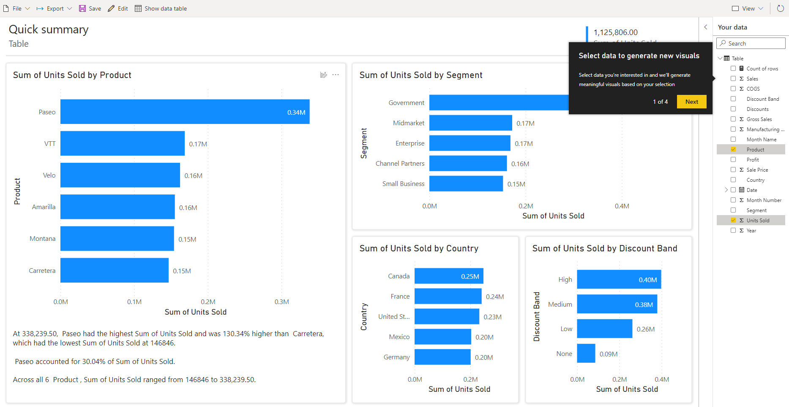

1. **Creating Reports using the Power BI Desktop Tool**

* Integrating your Data Source with Power Query:

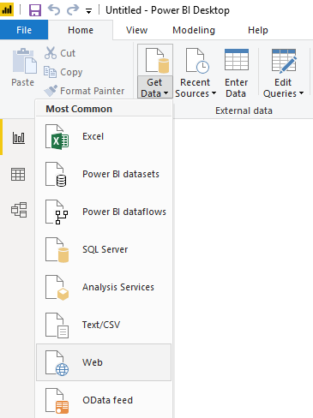

* Querying Data onto the Navigator:

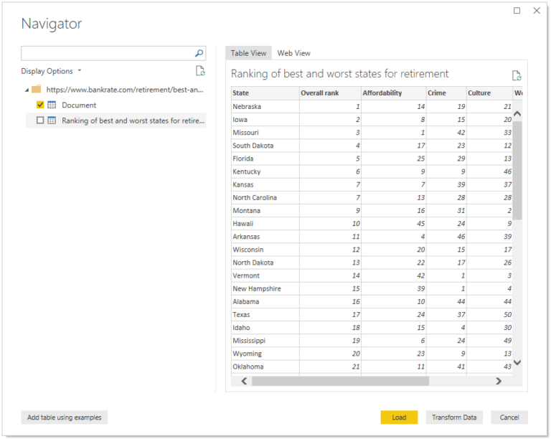

* Editing the Queries on the Table:

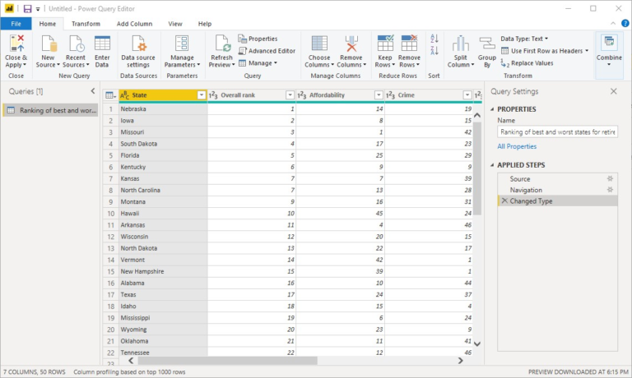

* Shaping the Data According to your Requirements

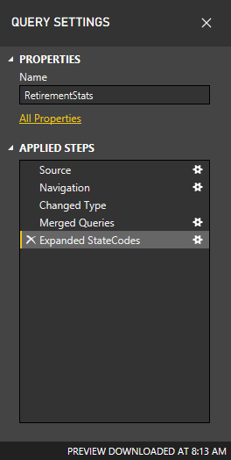

* Merging Queries from Different Tables

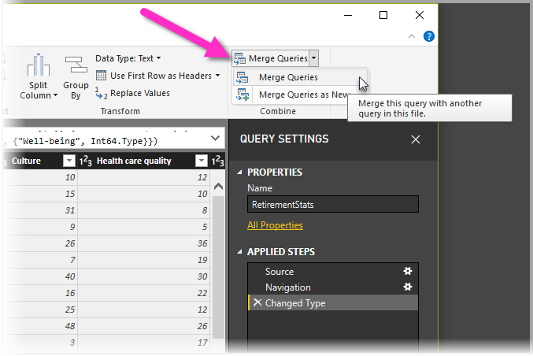

* Loading the Report onto the Power BI Desktop

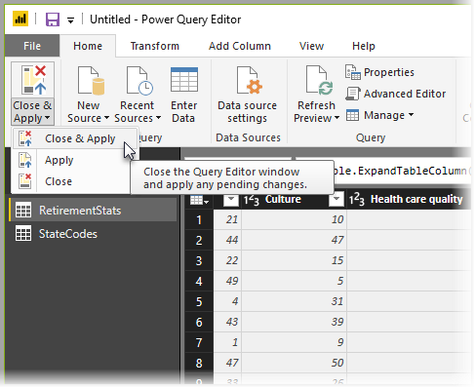

**4. How to connect to data in Power BI? How to use the content pack to connect to google analytics? Mention the steps.**

**Ans:**

To connect to data in Power BI from the home ribbon just select get data. To connect to Google analytics:

* launch Power BI desktop
* select get data from home ribbon
* in get data window click other
* from the list of other data sources, click Google Analytics
* click Connect
* click continue
* click accept
* click connect to load your data.

**5.How to import Local files in Power BI? Mention the Steps.**

**Ans:**

Manually import data to Power BI

* In Power BI, click Get Data in the lower left screen.
* Under Import or Connect to Data > Files, click Get.
* Click Local File.
* Choose which file to upload and click Open.
* Click Upload under Upload your Excel file to Power BI.
* The message “Your file has been uploaded” should appear.

**6.In Power BI visualization, what are Reading View and Editing view?**

**Ans:**

Power BI service has two different modes for interacting with reports: **Reading view** for report business users and editing view for report owners and creators. We would require a Power BI Pro or Premium per User (PPU) license to share reports and to edit reports created by others. Without a Pro or Premium per User (PPU) license, we can still create reports in our My Workspace section, but we can't share them.**Editing view** for report owners and creators.In Editing view, you have flexibility in both exploring and designing a report.